**Progress Report - Week 9**

Group name: Team A - VARS  
Group members: Rahil Patel, Vrund Patel, Sarthak Awasthi, Arpit Paranjpe

Our plan for the previous week:

* **Rahil Patel**
  + - Finished coding the front-end page for the main dashboard homepage
      * Added HTML for the link to the vaccine alert system page
      * Added HTML for ‘Symptoms of COVID-19’
        + Added functionality to redirect user to CDC website of symptoms when clicking ‘Read More’ button
    - Added CSS styling for the main dashboard homepage
      * Blue background for the vaccine alert system page
      * Mouse-hover background on the ‘Sign up’ button
      * Purple background for ‘Symptoms of COVID-19’
      * Mouse-hover background on the ‘Read More’ button

The above tasks were implemented in the below commit:



* + - Adjusted COVID news article content styling on the main dashboard homepage
* **Vrund Patel**
  + - Finished setting up the route handlers for making fetch requests to the server
      * Added the route handler which will make an Axios request to the API to retrieve the covid data based on the country passed in the query parameter.
      * Added the route handler which will make an Axios request to the API to retrieve the covid news based on the country passed in the query parameter.
    - Finished connecting the front-end country input to the server file by using the Fetch API to retrieve the API data from the server and display it to the client. Worked on this alongside Arpit (pai programmed).

The tasks above were implemented in the commit below:

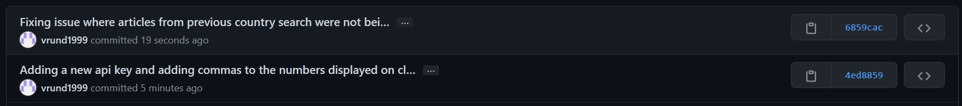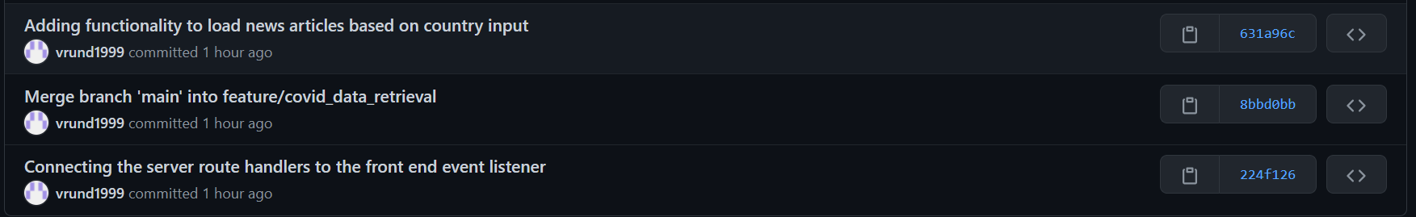



* **Sarthak Awasthi**
  + Worked on implementing auto-search suggestions feature for country search.
  + Created a JS file for script and added HTML content on the main web page for the feature.

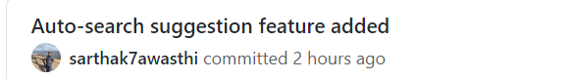

Demo: 

* **Arpit Paranjpe**
  + - Worked on implementing the HTML main webpage to display the covid data/news alongside Vrund (pair programmed).
    - Fixed any styling layout issues that were not initially addressed and implemented.

We are on track so far with what was planned in the last week. The second part of the project where we intend to send alerts for vaccine appointments will be starting in the upcoming week.

Our plan for the upcoming week is:

* **Rahil Patel**
  + - Work on getting the user information entered in the form of the alert page and add the information in MongoDB
    - Help setup email alert
* **Vrund Patel**
  + - Work on getting the user’s information like first name, last name, email address and their vaccine type and their next vaccine date and store this information in MongoDB and help setup the alert system which will send an email alert to anyone whose vaccine appointment is the next day.
* **Sarthak Awasthi**
  + - Work on creating the schemas/queries in MongoDB for storing the information. Planning to use JS mongo library for limiting the use of queries.
  + **Arpit Paranjpe**
* Work on the alert system which will send an email to those whose vaccine appointment dates are the next day.
  + We will be using the SMTP JavaScript library to send the emails to the users whose vaccine appointment is coming up.